**Perform the Extraction Transformation and Loading (ETL) process to construct the database in the SQL server / Power BI.**

STEP 1: EXTRACT – Load the Dataset into Power BI

1. Open Power BI Desktop.
2. Click on Home → Get Data → Text/CSV.
3. Select the file: superstore_dirty_dataset.csv.
4. In the preview window, click Load.

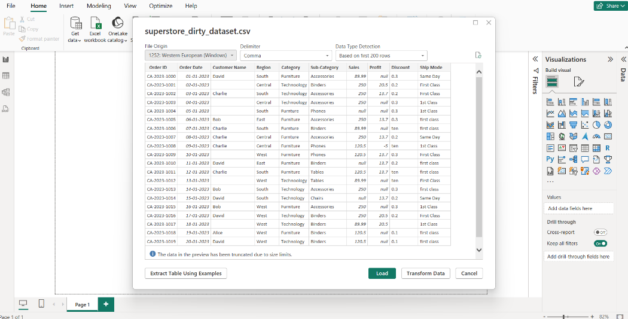

STEP 2: TRANSFORM – Clean the Data in Power Query Editor

Click Transform Data (from Home tab) to enter the Power Query Editor.

1. Handle missing values: 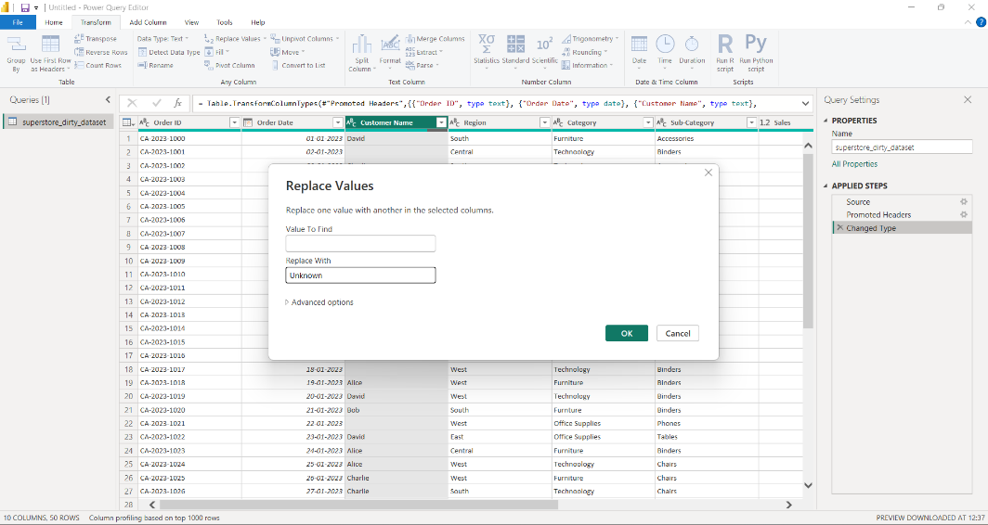
2. Handle Null values:
   * + Replace null with **mean** of the column.
     + Go to tannsfrom → Under Statistics tab select **average.** The mean of that colum will be calculated.
     + Select column → Transform tab → Replace Values → Replace null with the calculated mean.

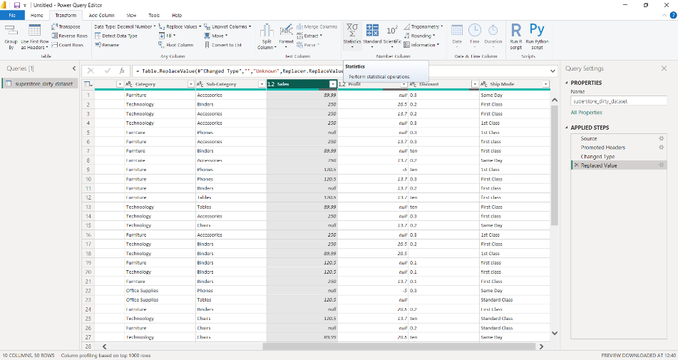

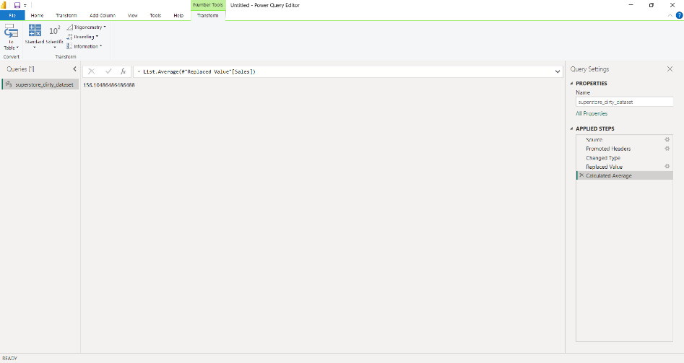

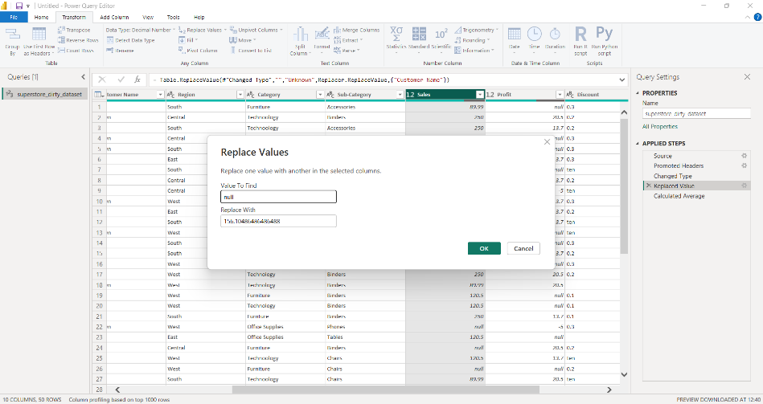

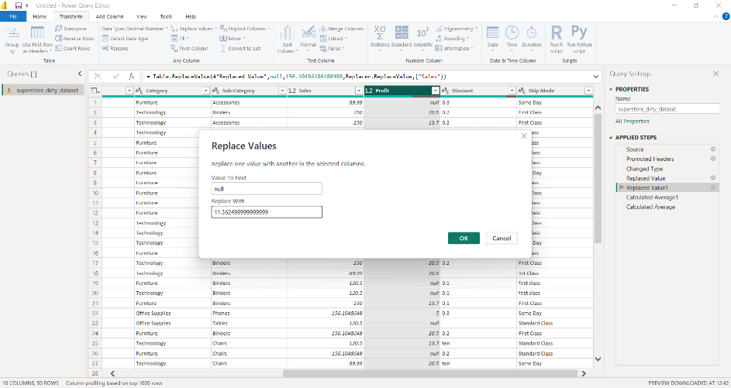

1. Fix Text Errors and Inconsistencies:

**1. Category Column (fix typos like "Technoology", "Furnture"):**

* + - Replace "Technoology" → "Technology"
    - Replace "Furnture" → "Furniture"
    - Method:
    - Right-click Category → Replace Values → Enter incorrect & correct spelling

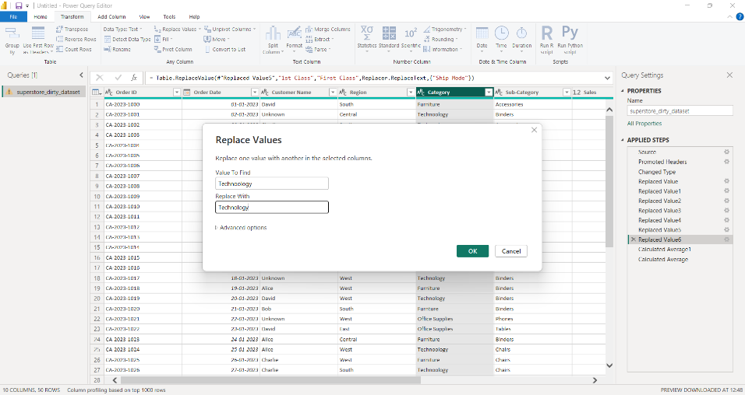

**2. Ship Mode Column:**

* + - Standardize formats:
    - Replace "1st Class" and "first class" → "First Class"
    - Right-click → Replace Values (repeat for each inconsistency)

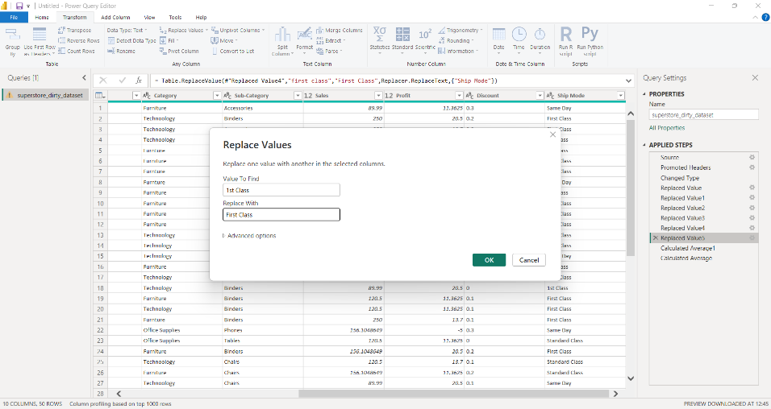

1. Fix Data Types
2. Discount Column:
   * + - Some values like "ten" or null are not numeric.
       - Step 1: Replace "ten" with 0.1 or your desired value.
       - Step 2: Change column type to Decimal Number
       - Click on the column → Data Type → Decimal Number

